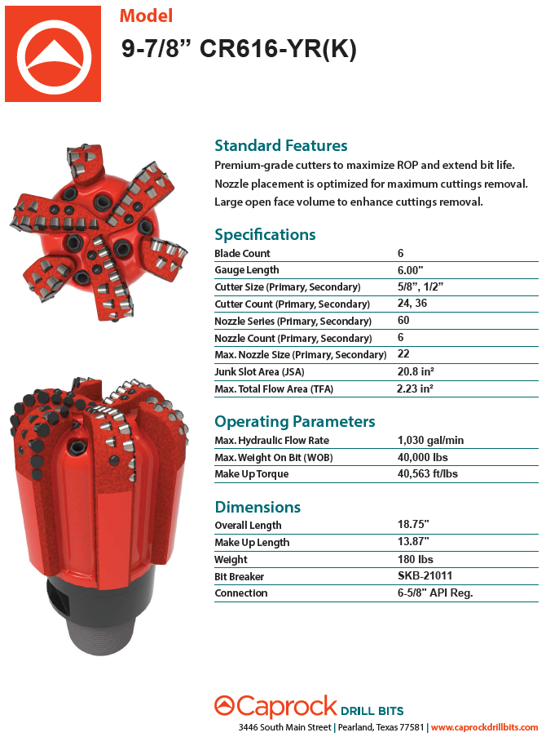

Highlights of the Ø9.875” 616-YR(K) design:
- Standard profile geometry
- 6" gage with straight wear pads
- The inner profile of bit body is smaller than the tool joint OD = Increased JSA.
- Offset back-up cutters on this bit will not engage until the primary cutters show significant signs of failure.

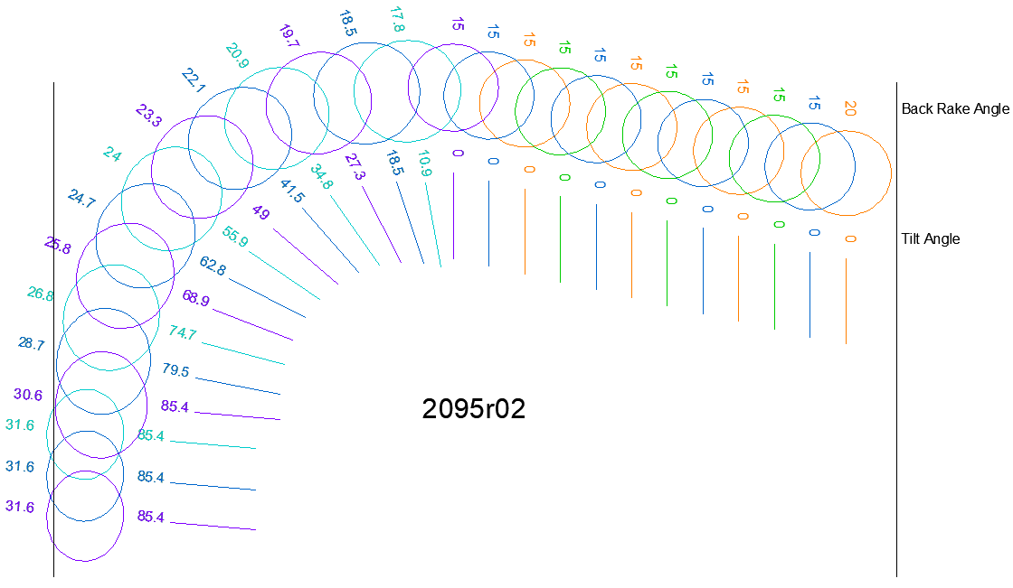

Blade 1 | Blade 2 | Blade 3 | Blade 4 | Blade 5 | Blade 6

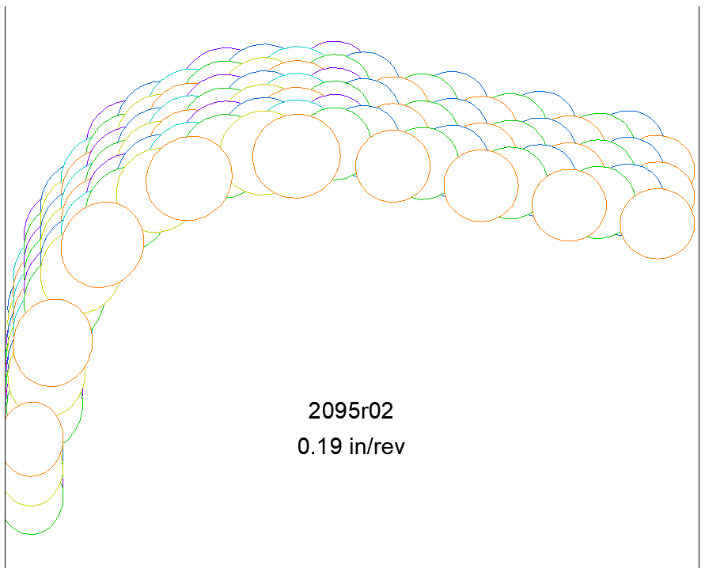
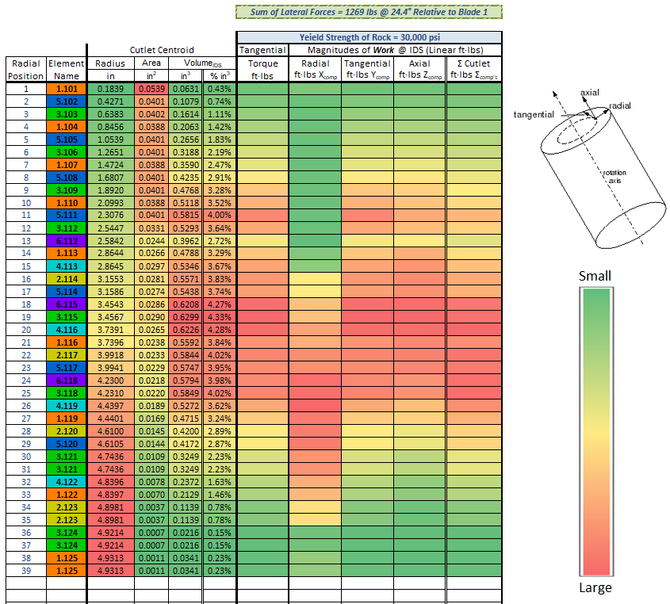

Radial Position: Position #1 is at the center of the bit. The position #’s increase with the radius.
Element Name:
- The # before the decimal is the blade # (the colors correspond to the drawings above).
- If the first # after the decimal is a 1, it’s a primary element position. If it is a 2, it’s a back-up position.
- The last two digits are the radial position.

